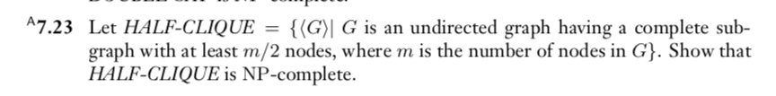

T = nondeterministic polynomial time for HALF-CLIQUE.

If T / 2 nodes form a CLIQUE, accept
Else reject

Thus HALF-CLIQUE ∈ NP

Use reduction for
CLIQUE ≤_{p} HALF-CLIQUE

<G, I>
G = graph
I = a interger

We have to determine if <G, I> ∈ CLIQUE

<G, T/2 > ⇔ <G> ∈ HALF-CLIQUE

Thus Half-Clique is NP-complete

